EXERCISE 3: SORTING CUSTOMER ORDERS

Name: Shubham Sangram Bej
AIM
To implement Bubble Sort and Quick Sort algorithms for sorting customer orders based on their total order price and compare their performance.

INTRODUCTION
Sorting is one of the most important operations in Data Structures and Algorithms. It is used to arrange data in a specific order, making searching, analysis, and processing more efficient. On an e-commerce platform, sorting customer orders by total price helps prioritise high-value orders and improve decision-making.
In this exercise, Bubble Sort and Quick Sort are implemented to sort customer orders. Additionally, other popular sorting algorithms such as Insertion Sort and Merge Sort are studied for comparison.
- BUBBLE SORT
Bubble Sort is a simple comparison-based sorting algorithm. It repeatedly compares adjacent elements and swaps them if they are in the wrong order. After each pass, the largest element moves to its correct position.
Algorithm:
- Start from the first element.
- Compare adjacent elements.
- Swap them if they are in the wrong order.
- Continue until the end of the array.
- Repeat the process until the array becomes sorted.
Time Complexity:
• Best Case: O(n)
• Average Case: O(n²)
• Worst Case: O(n²)
Advantages:
• Easy to understand and implement.
• Requires no extra memory.
Disadvantages:
• Inefficient for large datasets.
• Performs many unnecessary comparisons.
- INSERTION SORT
Insertion Sort builds a sorted array one element at a time. Each new element is inserted into its correct position within the already sorted portion of the array.
Algorithm:
- Consider the first element as sorted.
- Take the next element.
- Insert it into its correct position.
- Repeat for all remaining elements.
Time Complexity:
• Best Case: O(n)
• Average Case: O(n²)
• Worst Case: O(n²)
Advantages:
• Simple implementation.
• Efficient for small datasets.
• Performs well for nearly sorted data.
Disadvantages:
• Not suitable for large datasets.
• Performance decreases as data size increases.
- QUICK SORT
Quick Sort is a Divide-and-Conquer sorting algorithm. It selects a pivot element and partitions the array into two parts: elements smaller than the pivot and elements larger than the pivot. The same process is recursively applied to the sub-arrays.
Algorithm:
- Select a pivot element.
- Partition the array around the pivot.
- Recursively sort the left sub-array.
- Recursively sort the right sub-array.
- Combine the results.
Time Complexity:
• Best Case: O(n log n)
• Average Case: O(n log n)
• Worst Case: O(n²)
Advantages:
• Very fast for large datasets.
• Efficient average-case performance.
• Uses Divide-and-Conquer strategy.
Disadvantages:
• Worst-case complexity can be O(n²).
• Not a stable sorting algorithm.
- MERGE SORT
Merge Sort is another Divide-and-Conquer algorithm. It divides the array into smaller sub-arrays, recursively sorts them, and merges them back together.
Algorithm:
- Divide the array into two halves.
- Recursively sort both halves.
- Merge the sorted halves.
- Continue until the complete array is sorted.
Time Complexity:
• Best Case: O(n log n)
• Average Case: O(n log n)
• Worst Case: O(n log n)
Advantages:
• Consistent performance.
• Stable sorting algorithm.
• Suitable for large datasets.
Disadvantages:
• Requires additional memory.
• Slightly more complex to implement.
CLASS USED
Order Class
Attributes:
• orderId
• customerName
• totalPrice
The Order class represents a customer order and stores all relevant information required for sorting.

IMPLEMENTATION
The following sorting techniques were implemented:
- Bubble Sort
  - Orders are sorted by comparing adjacent order prices.
  - Swapping occurs whenever an order has a higher price than the next order.
- Quick Sort
  - A pivot element is selected.
  - Orders are partitioned around the pivot.
  - Recursive sorting is performed on both partitions.
PERFORMANCE ANALYSIS
Bubble Sort Complexity:
• Best Case: O(n)
• Average Case: O(n²)
• Worst Case: O(n²)
Quick Sort Complexity:
• Best Case: O(n log n)
• Average Case: O(n log n)
• Worst Case: O(n²)
Comparison:
Feature | Bubble Sort | Quick Sort
Best Case | O(n) | O(n log n)
Average Case | O(n²) | O(n log n)
Worst Case | O(n²) | O(n²)
Large Dataset Performance | Poor | Excellent
Efficiency | Low | High

WHY QUICK SORT IS GENERALLY PREFERRED
- Better Time Complexity
Quick Sort has an average complexity of O(n log n), whereas Bubble Sort has O(n²). Therefore, Quick Sort is much faster for larger datasets.
- Better Scalability
As the number of customer orders increases, Quick Sort performs significantly better than Bubble Sort.
- Divide and Conquer Strategy
Quick Sort divides the problem into smaller subproblems, making it more efficient and reducing overall sorting time.
- Industry Usage
Quick Sort is widely used in real-world applications because of its speed and efficiency.
OUTPUT
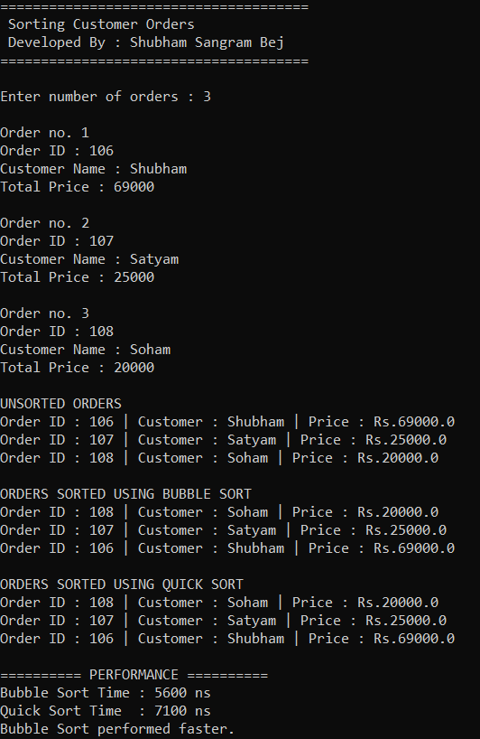
RESULT
The program successfully sorted customer orders based on total order price using both Bubble Sort and Quick Sort. The performance comparison showed that Quick Sort is generally more efficient and suitable for large datasets, while Bubble Sort is useful only for small datasets and educational purposes.
CONCLUSION
In this exercise, customer orders were sorted using the Bubble Sort and Quick Sort algorithms. The time complexity and performance of both algorithms were analysed and compared. Quick Sort proved to be the better choice for large datasets due to its superior average-case performance and scalability. This exercise demonstrated the importance of selecting appropriate sorting algorithms in real-world applications such as e-commerce systems.

